**Collisions**

https://www.youtube.com/watch?v=JchlOld1rJI&index=50&list=PLRtjMdoYXLf776y4K432eL_qPw4na_py3

#include "stdafx.h"

#include "SFML/Graphics.hpp"

#include <iostream>

#include <windows.h>

int main()

{

sf::RenderWindow window (sf::VideoMode(640, 480), "SFML works!");

sf::Texture texture;

texture.loadFromFile("shape.png");

sf::Sprite sprite;

sf::Sprite sprite2;

sprite.setTexture(texture);

sprite2.setTexture(texture);

sprite2.setPosition(0, 400);

while (window.isOpen()) {

sf::Event event;

while (window.pollEvent(event))

{

switch (event.type)

{

case sf::Event::Closed:

window.close();

break;

}

}

if (sprite.getGlobalBounds().intersects(sprite2.getGlobalBounds()))

{

std::cout << "Sprites have intersected" << std::endl;

}

else

{

sprite2.move(sf::Vector2f(0, -0.5));

}

window.clear();

window.draw(sprite);

window.draw(sprite2);

window.display();

}

}

**Result**

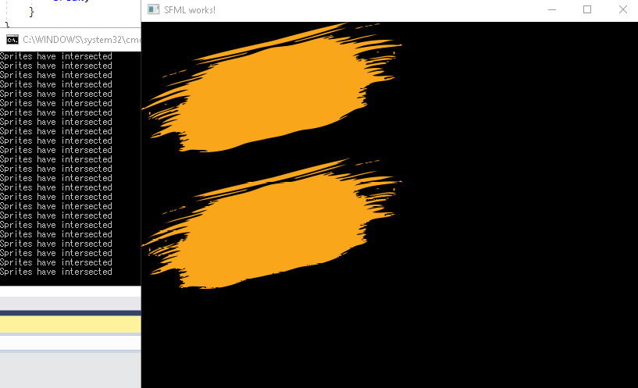

**Important notes:**

* It wasn’t the actual sprite textures that collided, but the square sprites
* To find the global bounds, in our case, we used the code sprite.getGlobalBounds().intersects(sprite2.getGlobalBounds())